**Kol simcha torah gazette**

**For parshas vayishlach 5784**

Volume 8 Issue 12 (Whole #370) 19 Kislev 5784/ December 2, 2023

**Printed L’illuy nishmas Nechama bas R’ Noach, a”h**

For a free subscription, please forward your request to [***keren18@juno.com***](mailto:keren18@juno.com)

***Past emails can be found on the website ShabbosStories.com under Brooklyn Torah Gazette***

**The Miracle of the**

**Return of Torah**

**Learning to Eretz Yisroel**

**By Daniel Keren**

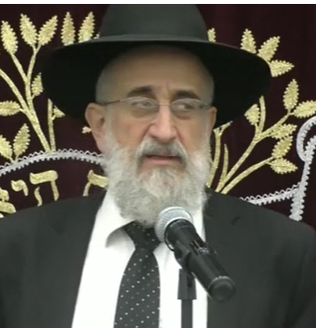

**Rabbi Yisroel Reisman**

One of the featured speakers at the recent 2023 Flatbush Veterans Day Hakhel Event was Rabbi Yisroel Reisman, mora d’asra of the Agudath Israel of Madison. He began by noting that all of us today feel the horrors and fears of the war in Gaza. It is a time for us to daven, pray to Hashem that the Bnei Yisroel, the Jewish people should enjoy periods of shalom, peace.

In his Veterans Day lecture, Rabbi Reisman focused on Perek Daled (Chapter 4) of Sefer Micha that is found in Sefer Trei Asar (the Book of the Twelve Minor Prophets). “And it shall be at the end of the days, that the mountain of the L-rd's house shall be firmly established at the top of the mountains, and it shall be raised above the hills, and peoples shall stream upon it. And many nations shall go, and they shall say, ‘Come, let us go up to the L-rd's mount and to the house of the G-d of Jacob, and let Him teach us of His ways, and we will go in His paths,’ **for out of Zion shall the Torah come forth, and the word of the L-rd from Jerusalem.** And He shall judge between many peoples and reprove mighty nations afar off; and they shall beat their swords into plowshares, and their spears into pruning hooks; nations shall not lift the sword against nation; neither shall they learn war anymore.” (Micha 4:1-3)

**A Different Location for the Bayis Shlishi (Third Temple)**

Rabbi Reisman noted that the Prophet Yechezkel (Ezekiel) predicts that when Moshiach comes and the Bayis Shlishi (Third Temple) will be built, it won’t be on the Temple Mount near the Kosel (the Western Wall) where the first two Holy Temples were built by Shlomo (King Solomon) and Ezra. Rather the Third and eternal Beis Hamikdosh will be built 45 mil (or 30 miles) to the north of the Temple Mount.

The Rambam writes that the concept of “**Ki Mi’Tzion teitzei Torah/for out of Zion shall the Torah come forth…**” refers to the Jewish people’s study of the Torah. The ability for navuah, prophecy can only begin in the Land of Israel. Once a navi has gained such prophecy, he can then deliver such navuah even in chutz la’aretz, outside of the Holy Land.

If the concept of Torah must come from Yerushalayim, the holy city of Jerusalem, why do we primarily study the Talmud Bavli that was developed in Babylonia as opposed to learning from the Talmud Yerushalmi that was composed by Torah scholars in the Holy Land?

**Rebounding in Both Our Torah Learning and Ruchnius**

Rabbi Reisman explained that many times tragedy befalls Klal Yisroel and it seems that Hakodesh Baruch Hu is distant from us. Throughout Jewish history we find that it is the result of such unwanted tragedies that have struck the Jewish people that we have rebounded by increasing in both our Torah learning and in our ruchnius (spiritual service to Hashem).

The reason why we paskin (determine the halacha or Jewish law practice) from the Babylonian Talmud is that it was composed by Torah scholars in the painful difficulties of galus, exile. Sometimes the darkness of galus and its challenges can offer us an ability to strengthen our Torah study [and our connection to Hakodesh Baruch Hu.]

Rabbi Reisman pointed out that Rav and Shmuel opened respective yeshivas in Bavel, Babylonia in the towns of Sura and Pumbadisa. These two yeshivas lasted for almost a thousand years. For almost 2,000 years until recently, the center of Torah learning during our current galus was always in chutz la’aretz. It is only recently now that the focus of Torah learning has returned to Eretz Yisroel.

**Rejoicing in the Resurgence of Torah Learning Today**

Do we realize that Ki Mi’Tzion teitzei Torah mi ’Yerushalayim has returned? Rabbi Reisman declared that in just one generation we are the Dor Haria that witnessed the mesorah (tradition of Torah learning) return to the Land of Israel. Therefore, we have to look at what is happening now in Eretz Yisroel and rejoice at the miracles that are happening, especially with the resurgence of Torah observance. One has to appreciate the kindness of Hakodesh Baruch Hu.

The reestablishment of the Yishuv (the Jewish presence in the Holy Land) was a greater brocha, blessing to the non-frum (secular Jews living in Israel.) They are not suffering the high rate of intermarriages in Eretz Yisroel as there are among the Jews living in America [and other countries in the Diaspora]. We have to recognize this as a nes (miracle) from Hakodesh Baruch Hu.

**The Disrespect Precious Gift**

Imagine someone gave another person an important and precious gift. But the recipient does not respond appropriately by showing an appreciation for what he has received, perhaps causing the giver to regret having bestowed the gift. The giver may even want to take back the gift temporarily until the person who initially received it will now recognize his loss and regrets his behavior in not appreciating what he was given. Perhaps, Rabbi Reisman offered, that might explain what is happening to us today.

Eretz Yisroel is the makom, the best place, to learn Torah. It is closer to the ultimate source (Hakodesh Baruch Hu) and a better influence for one [to live in.] So, the Navi Micha prophesizes that in the final days there will be serenity in Eretz Yisroel. Our dream is for the fulfillment of that navuah. But, we have to deserve it.

Hakodesh Baruch Hu gave us such brocha in Eretz Yisroel. If we truly appreciate it, we will get even more blessings. Let us hope that each and every one of us should see good news for not only security in Eretz Yisroel but also for all Jews around the world [leading to the long-awaited coming of Moshiach.]

*Reprinted from the December 1, 2023 edition of The Jewish Connection.*

**Rav Avigdor Miller on How Are We to Think of the Con-servative and Reform Jews**

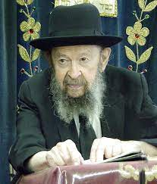

The question is, what do you mean by that? Certainly, they’re not frum Jews. But they certainly are Jews. As soon as a Conservative Jew or Reform Jew does teshuvah, he’s a Jew; he doesn’t have to go through any ceremony of conversion. So therefore, they certainly are Jews.

But there are ‘Jews’, and then there are Jews. In one sense, they’re Jews. In a technical sense they are Jews because they were born from Jewish mothers. But the love that we have to feel towards our fellow Jews does not extend to Reform Jews. Because in the sense of sharing in the privileges of being part of the Jewish nation, no, they certainly have no share in those privileges.

Now, some people don’t like to hear that, but I’m talking the truth. It’s hard to love your fellow Jew. It takes work. Some people bandy the word ‘love’ around, they love ‘everybody’ they say. But the truth is that they don’t even love their own brothers and sisters. That’s the plain truth, they don’t get along with their siblings and now they’re willing to love everybody?!

The answer is that it’s a phony. It’s all a bluff. You know, it’s hard to love a fellow Jew. It’s very difficult. And now you want to go and extend it to everybody? Don’t be ridiculous! In order to love somebody like you love yourself, he has to be like yourself. And if he doesn’t have your ideals, then you can’t love him like yourself. Certainly, you should try to help them. Certainly.

You have to help goyim too. And a fellow Jew who is not observant, if you can lead him back to Judaism, that’s a very big mitzvah. Of course, we have pity on him and we care about him and so we’ll try to bring him back. But to say that you have to love him like you love yourself? No, that’s out of the question.

*Reprinted from the Parshas Vayeitzei 5784 email of Toras Avigdor based on Tape #490 (December 1983).*

**Thoughts that Count**

**for Parsha Vayishlach**

*My lord knows that the children are tender* (Gen. 33:13)

Why did Jacob make a point of mentioning the children in response to Esau's invitation to join him? Because being in Esau's proximity was much more of a threat to his impressionable children than it was to himself. Unpleasant as it might have been for him, maintaining his children's spiritual purity was his number one priority. *(Rabbi Yehoshua Rokeach of Belz)*

*Because he had wrought a vile deed in Israel...that ought not to be done* (Gen. 34:7)

There are certain crimes for which the punishment involves inflicting the same offense against the criminal who committed them. For example, if a person steals, he must make monetary restitution; if he commits murder, he is subject to capital punishment. The "vile deed" that was committed against Dina, however, was not in this category, and can never be humanly rectified in this manner. *(Kanfei Yesharim)*

*Reprinted from the Parshat Vayishlach 5761/2000 edition of L’Chaim.*

**The Jew’s Spiritual Mission:**

**The Refinement of Evil**

**From the Teachings of the Lubavitcher Rebbe**

**Rabbi Menachem Mendel Schneerson, Zt”l**

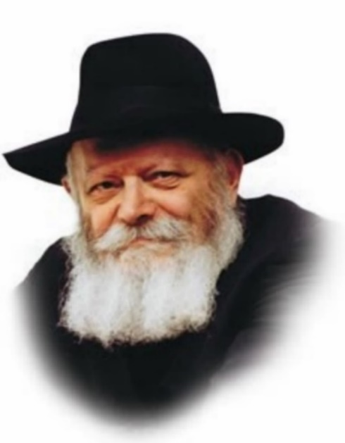

The first of the Five Books of Moses, Bereishit (Genesis), is also called the "Book of the Just," as it narrates the lives of our ancestors, whom the Talmud refers to as "just." As it is axiomatic in Judaism that "the deeds of the ancestors are a sign for their descendants," it follows that Genesis is the "blueprint" for all Jews in their service of the Creator. In other words, Genesis teaches us how a Jew is supposed to live.

**The Basic Awareness of G-d’s Creation of the World**

This idea is expressed in the names of the Torah portions themselves. The first portion in Genesis is Bereishit ("in the beginning"), which instills the basic awareness that G-d created the world for the Torah and for the Jewish people. The second portion, Noach, alludes to the ultimate objective in the world's creation: to bring nachat ruach (pleasure; linguistically related to the name Noach) to G-d by fulfilling His desire for a "dwelling place" in the physical realm.

The next portion, Lech Lecha ("go out"), describes the dynamics of how this is accomplished: The soul is forced to leave the higher spiritual realms and become enclothed in a corporeal body, where it is constantly urged to transcend the level it has already attained and climb to the next.

Vayeira ("and He appeared") refers to G-d's special revelation to every Jewish soul, which assists us in our Divine mission.

This G-dly revelation penetrates all aspects of the soul, hinted at in the name of the next Torah portion, Chayei Sara ("the life of Sara"). Sara lived 127 years, which is an esoteric allusion to all of the soul's powers. Once G-d gives us these capabilities, we are then able to create Toldot ("generations" or "descendants"), as our Sages stated, "The descendants of the righteous are their good deeds."

**The Jew’s Obligation to Send Out “Messengers”**

After this basic outline has been defined, the Jew's service is further elucidated in the next two portions, Vayeitzei ("and he went out") and especially in this week's Torah reading, Vayishlach ("and he sent"). "And Jacob went out from Beersheba and went to Charan" refers to the Jew's spiritual journey to even the very lowest levels of existence for the purpose of elevating them. But even that is not enough. The Jew must then send out "messengers" to Esau, symbolic of the antithesis of G-dliness and holiness, to purify and refine these realms as well.

**The Complete Unification of the Jews and G-d**

The next portion, Vayeisheiv ("and he dwelt"), refers to G-d enabling us to live in peace and tranquility, which leads to Mikeitz ("at the end") - the successful completion of our mission. All Jews will be completely united with G-d (Vayigash -"and he came near"), which will then culminate in eternal life with the resurrection of the dead (Vayechi - "and he lived").

However, the main part of our mission - the refinement of evil and its transformation into good, in preparation for Moshiach's coming - is contained in this week's Torah portion.

*Reprinted from the Parshat Vayeitzei 5761/2000 edition of L’Chaim. Adapted from Volume 1 of Hitva’aduyot 5750.*

*\*\*\*\*\*\*\*\*\*\*\*\*\*\*\*\*\*\*\*\*\*\*\*\*\*\*\*\*\*\*\*\*\*\*\*\*\*\*\*\*\*\*\*\*\*\*\*\*\*\*\*\*\*\*\*\*\*\*\*\*\*\*\*\*\*\**

*Then Jacob was greatly afraid and distressed; and he divided the people...into two camps* (Gen. 32:8)

The great Chasidic masters interpreted this verse as follows: Why was Jacob "afraid and distressed"? Because the Children of Israel were "divided." Jacob knew that when the Jewish people stand united, Esau is powerless against them. It is only when Jews are splintered into different camps that there is something to worry about... *(Maayanot Netzach)*

*Reprinted from the Parshat Vayishlach 5761/2000 edition of L’Chaim.*

**Rabbi Berel Wein on**

**Parshat Vayishlach 5784**

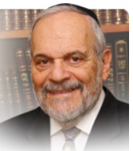

Many commentators over the ages have seen in the two confrontations between Yaakov and Eisav – first the struggle with Eisav’s angel and then the meeting with Eisav in the flesh – the two-front war that Judaism and the Jewish people have been forced to fight over millennia in order to simply survive.

The struggle with Eisav’s angel, as described in the parsha, represents a spiritual and intellectual fight, a contest of ideas, beliefs and debate. The meeting with the physical Eisav in turn represents the struggle of the Jewish people to simply stay alive in a bigoted, cruel, and nearly fatal environment.

Yaakov does not escape unscathed from either confrontation. He is crippled physically and somewhat impoverished financially. Eisav’s “evil eye” gazes upon his children and Yaakov is relieved to escape alive, even if damaged in body and purse, separating himself from Eisav physically and from his civilization and worldview.

The scenario is pretty much set for the long dance of Jewish history, with the Jews always attempting to survive in a constantly challenging and brutal society governed by Eisav. The rabbis of Midrash discussed the possibilities of coexistence and even cooperation with Eisav.

Though this debate did not result in any permanent or convincing conclusion, the opinion of Rabbi Shimon ben Yochai that Eisav’s hatred of Yaakov is completely irrational and implacable seems to be borne out by history, past and present. The anti-Semitism in today’s seemingly enlightened world is so pervasive as to be frightening. And we seem to be powerless to do anything about it.

As is painfully obvious to all, these struggles for continued Jewish existence are ongoing and seemingly unending. All of the foreign ideas and current fads of Western society stand almost unanimously opposed to Torah values and traditional lifestyle. The angel of Eisav changes his program from time to time, but he is always opposed to Torah and moral behavior.

He wavers from totalitarian extreme conservatism to wild liberalism but always is able to wound the Jewish psyche and body no matter what philosophy or culture he now advocates. We limp today from this attack on Jewish values and Torah study and practice.

Jewish parents in America sue school boards for anti-Semitic attitudes, policies and behavior. Yet they would not dream of sending their children to a Jewish school or giving them an intensive Jewish education. The lawsuit is the indicator of the limp inflicted upon us by Eisav’s cultural angel.

All agree that Europe is currently a lost continent as far as Jews are concerned. The question most asked of travel agents by Jews today is “Can I wear a kippah on the street there?” Billions of dollars of Jewish treasure pillaged during World War II and immediately thereafter still lie in the hands of Eisav.

And yet we certainly would be satisfied if the world just let us alone but that seems to be a forlorn hope. So, our struggle continues but the L-rd’s promise to us that we will somehow prevail remains valid and true. And that is our hope for continuing on as loyal and steadfast Jews.

*Reprinted from the current website of rabbiwein.com*

**Jews from Arab Lands: The Middle East’s Forgotten Refugees:**

**By**[**Will Barclay**](https://aish.com/authors/will-barclay)

***By the end of the 1970’s, 900,000 Jews were expelled from Islamic states and Muslim nations around the world.***

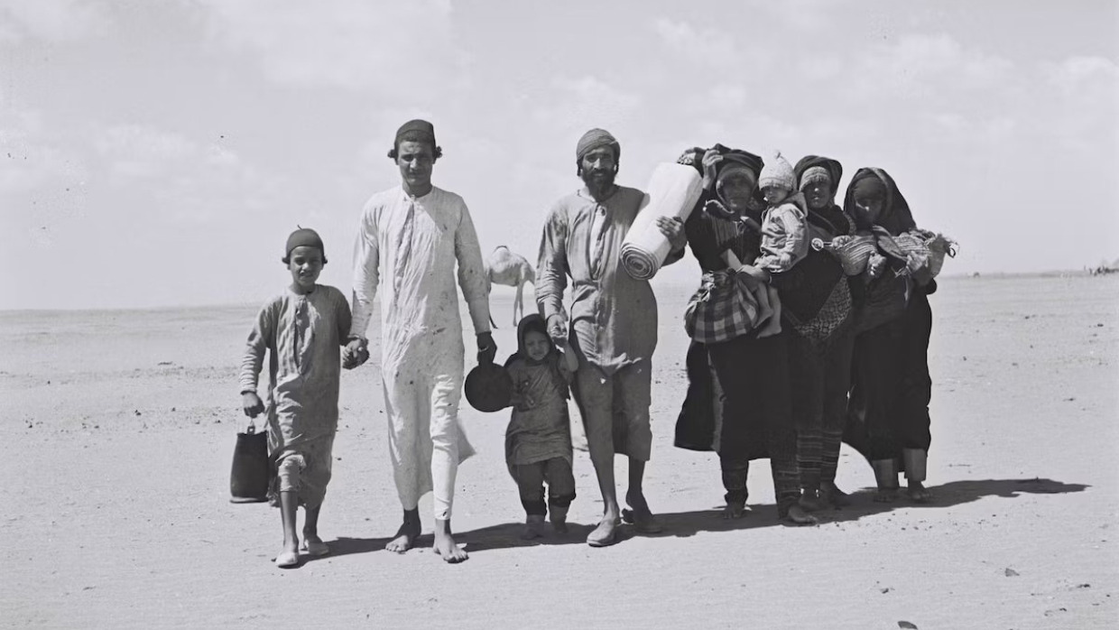

In 1947, the United Nations (UN) adopted UN Resolution 181 and, thereby, resolved to subsequently divide Great Britain’s former Mandate into Palestinian and Jewish states.1

Although the international community and the Jewish People eagerly embraced UN Resolution 181, all of the Arab nations that surrounded the nascent state of Israel immediately vowed to exterminate the newborn Jewish state.2

Numerous Arab and Muslim leaders also explicitly declared that they would severely punish and expel any Jews who elected to remained within their territories.

For example, in 1947, Syria’s Permanent Representative to the United Nations, Faris el-Khouri, stated that “Unless the Palestine problem is settled, we shall have difficulty in protecting and safeguarding the Jews in the Arab world.”3 In addition, the Prime Minister of Iraq, Nuri al-Said, proudly declared that "…if a satisfactory resolution to the Palestine case was not reached, severe measures should be taken against all Jews in Arab countries."4

*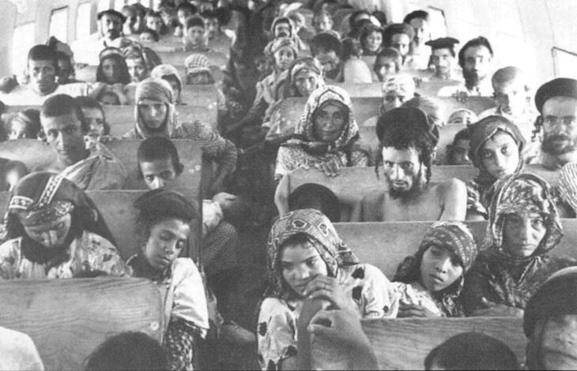Yemeni Jews aboard a plane during the Operation Flying Carpet, 1949 (Credit: Wikimedia Commons)*

Consequently, when the state of Israel was ultimately founded in 1948, swathes of Jews from Arab and Muslim countries were slaughtered and violently expelled from their ancestral homes and communities. In fact, over 90% of the Jewish population in Iraq and Yemen was forced to escape with only their lives in tow.5

**Yemen boasted a Jewish population of 55,000 in 1948. By 2016, only 50 Jews remained.**

Yemen, for instance, boasted a Jewish population of 55,000 in 1948.6 Due to the rampant antisemitism that plagued [Yemeni Jews](https://aish.com/history-of-the-jews-of-yemen/) after the advent of the state of Israel, 50,000 Jewish people were quickly forced to evacuate from Yemen between 1949 and 1950.7 By 2016, only 50 Jews remained in all of Yemen.8

Moreover, approximately 160,000 Jewish people inhabited Iraq in 1948.9 However, after the state of Israel was founded, Iraq was placed under martial law and the state of Iraq actually amended its own respective Criminal Code, in order to render Zionism a criminal activity and punishable by death.10 In fact, Shafiq Adas, a famous Jewish magnate and “the richest Jew in Iraq”, was arrested and publicly hanged, due to the fact that he allegedly sold goods to the state of Israel.11

Furthermore, Iraq's Prime Minister, Nuri al-Said, personally campaigned to violently excise and eliminate Iraq’s Jewish population. According to Britain’s Ambassador, Sir Alec Kirkbride, “Nuri Said…came out with the astounding proposition that a convoy of Iraqi Jews should be brought over [to Israel] in army lorries escorted by armored cars… Either the Iraqi Jews would have been massacred or their Iraqi guards would have had to shoot other Arabs to protect the lives of their charges.”12

By the end of 1952, nearly 130,000 Jews had fled Iraq, and, by 2004, Iraq’s vibrant Jewish community was reduced to a paltry 35 Jews in Baghdad.13

*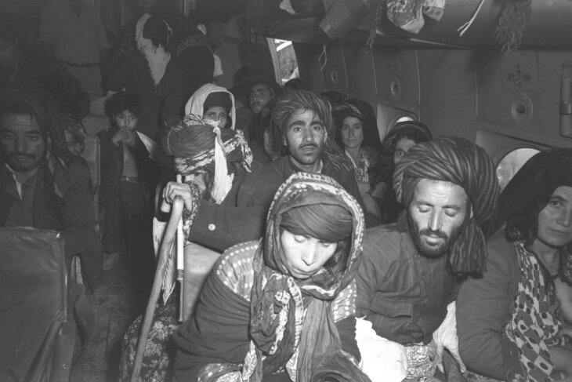Immigrants from Iraq soon after landing at Lod Airport, summer 1951 (Teddy Brauner, GPO)*

Ultimately, 900,000 Jews were violently expelled from Islamic states and Muslim nations around the world by the end of the 1970’s.14 However, throughout the modern era, the international community and human rights activists have focused their efforts overwhelmingly on the 360,000 Palestinians that were displaced as a result of the outbreak of the Israel-Palestine Conflict.15

The reality that countless Jews were murdered and savagely displaced from their ancestral homes and communities that they lovingly inhabited for well over 2500 years has become forgotten, and is, in fact, often unabashedly ignored by modern political actors because the international community is unwilling to confront the intergenerational antisemitism that has permeated throughout the Middle East for millennia.

**Works Consulted**

Basri, Carole. “The Jewish Refugees from Arab Countries: An Examination of Legal Rights-A Case Study of the Human Rights Violations of Iraqi Jews”. in *Fordham International Law Journal*. 2002.

“[Jews in Islamic Countries: Iraq](https://www.jewishvirtuallibrary.org/jews-of-iraq)”. *Jewish Virtual Library.*[8 November 2023].  
“[Jews in Islamic Countries: Yemen](https://www.jewishvirtuallibrary.org/jews-of-yemen)”. *Jewish Virtual Library*. [8 November 2023].  
Ministry of Aliyah and Integration. *“*[*On Eagles’ Wings”–Aliyah from Yemen*](https://www.gov.il/en/Departments/Guides/the-aliya-story?chapterIndex=7)*(1949).*2022.[8 November 2023].

Morris, Benny. *1948: A History of the First Arab-Israeli War.*Yale University Press, 2008.

“[Quotes from Arab and Islamic Leaders Regarding Jews and Israel](https://www.jewishvirtuallibrary.org/myths-and-facts-quotes)”. *Jewish Virtual Library*. [8 November 2023].

United Nations. *Progress Report of the United Nations Mediator on Palestine: In pursuance of paragraph 2, part II, of resolution 186 (S-2) of the General Assembly of 14 May 1948.* 1948.

United States Department of State: Office of the Historian. [*Milestones: Creation of Israel*](https://history.state.gov/milestones/1945-1952/creation-israel)*, 1948.*[8 November 2023].

United States Department of State: Office of the Historian. [*Milestones: The Arab-Israeli War of 1948*](https://history.state.gov/milestones/1945-1952/arab-israeli-war). [9 March 2023].

*Reprinted from current website of aish.com*

*\*\*\*\*\*\*\*\*\*\*\*\*\*\*\*\*\*\*\*\*\*\*\*\*\*\*\*\*\*\*\*\*\*\*\*\*\*\*\*\*\*\*\*\*\*\*\*\*\*\*\*\*\*\*\*\*\*\*\*\*\*\*\*\*\*\**

Yaakov sent a message to his brother Esov I have lived by Lavan (32:5) and Rashi adds the word is the numerical value of six hundred and thirteen, I lived by Lavan and yet kept the six hundred and thirteen Mitzvos and did not learn from his evil ways. Why did Yaakov send a message to Esov that he didn’t learn from Lavan’s evil ways? Why would Esov care if Yaakov fulfilled the Mitzvos or not?

Yaakov was afraid that Esov would agree to forget the past and become friends. Live near each other, let their children be friends, share their lives with each other. Yaakov sent the message to Esov - we can be friends and everything that goes with it - but remember, I fulfilled all the Mitzvos. I will agree to any peace treaty you wish as long as it doesn’t compromise Torah and Mitzvos. (Rabbi Moshe Feinstein)

*Reprinted from the Parshat Vayishlach 5784 email of R’ Yedidye Hirtenfeld’s whY I Matter parsha sheet for the Young Israel of Midwood in Brooklyn, NY.*

**Insights into this Week’s Parsha**

And Esav ran toward him, and he embraced him and fell upon his neck and kissed him. (33:4) The Midrash says Esav did not come to kiss Yaakov, but rather to bite Yaakov. But the Pasuk says to kiss him? A kiss from a person like Esov, is in reality a bite to Yaakov. Yaakov doesn’t need friends like that. Friendship and love from Esov, causes pain and hardship to Yaakov. (Chidushei Hori"m of Gur)

Now, let my master go ahead before his servant, and I will move at my own slow pace, according to the pace of the work that is before me and according to the pace of the children, until I come to my master, to Seir. (33:14) Jacob promised to visit Esau at his home in Seir. However, he never went to Seir. Did Jacob lie? No. For he will go in the days of Moshiach, as it is says (Obadiah 1:21): "And saviors shall ascend Mt. Zion to judge the mountain of Esau." (Rashi)

Let my master go ahead of his servant; I will make my way at my slow pace (33:14) The midrash says: Esav asked Yaakov, "Are you not afraid of the powerful and frightful individuals that you will meet along your way?" Yaakov answered, "I will go along gently and softly." Rav Henach Lebowitz (son of Rav David Lebowitz) says that this midrash teaches us the Jewish way in exile, where the gentiles have the upper hand. We do not challenge our enemies; we go about our business quietly and in an unobtrusive way, and then we need not be afraid. (Chiddushei Halev)

And Esau said: Please let me leave with you some of the people that are with me (33:15) Esau suggested that he leave special teachers with Yakov and his family, to teach them the finer points of "civilization" - social conventions, foreign languages and popular fashions - so that they could quickly climb the social ladder, but Yakov refused his brother's offer. "What need is there?" Yakov replied. "I have no interest in assimilating, to find favor in your eyes or the eyes of the nations." (Chasidic Sages)

*Reprinted from the Parshat Vayishlach 5784 email of R’ Yedidye Hirtenfeld’s whY I Matter parsha sheet for the Young Israel of Midwood in Brooklyn, NY.*